**MEASURE OF VARIANCE**

**Variance:**

Variance , the statistical measurement that implements to determine spread of numbers with in the datasets. ”The degree to which numerical data tend to spread about an average value is called variation or dispersion of data. Dispersion is the measure of extent to which individual item vary.

**Property for an ideal measure of dispersion:**

It should be rigidly defined

It should be based on all observations.

In variance, we found two types of data that is grouped data and ungrouped data. When we express data in the form of class intervals then it is called grouped data, while on the other hand data consists of individual point called ungrouped data.

**There are two types of Variance in statistics:**

Sample Variance

Population Variance

**Population variance**

If we had collected the data from every person from the population  that we ’re interested in, then we got the exact value for population variance.

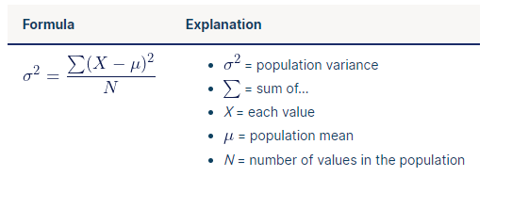

**Sample variance:**

When we mostly used to collect the data from the samples , then at that time the sample variance used to made estimates or inferences about the population variance.

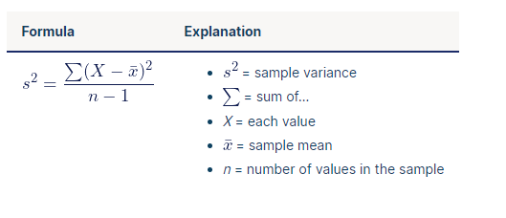

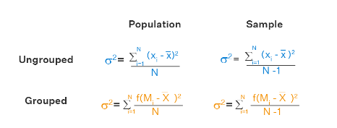

**Measures of Dispersion:**

Various measures of dispersion are classified into two broader categories:

1. The measures which express the spread of observations in term of distance between the values of selected observations. These termed as distance measures, ex . range and interquartile range
2. The measures which express the spread of observations from some central value, e.g., mean deviation and standard deviation

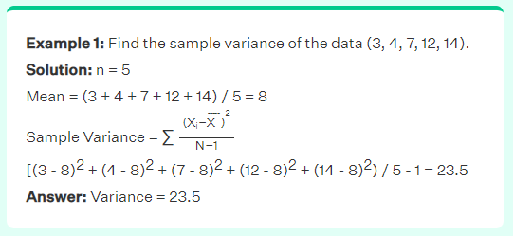

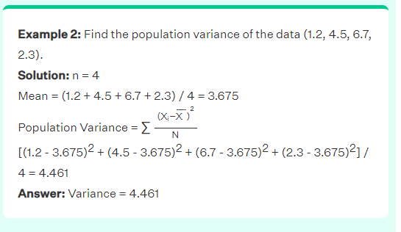

**Range:**

The range is the difference between two extreme observations of the distributions. If A and B are the greatest and smallest observations respectively in a distribution then its range is given by:

**Range= Xmax- Xmin =A-B**

**Quartile Deviation:** Quartile Deviation or semi- interquartile range Q is given by:

**Q=1/2(Q3-Q1)**

Where Q1=first quartile of distribution

and Q3 = third quartiles of distribution

Quartile Deviation id definitely a better measure than the range as it makes use of 50% of the data. But since it ignores the other 50% of the data , it cannot be regarded as a reliable measure.

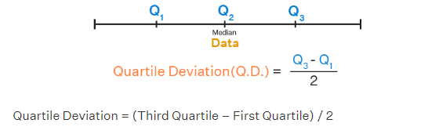

QD can also be calculated for both the grouped data and the ungrouped data. It measured the absolute level of dispersion and it is not affected by the extreme values.

Coefficient of Quartile deviation can be calculated by this formula

Coefficient of Quartile Deviation = (Q3 – Q1) / (Q3 + Q1)

**Standard Deviation and Root Mean Square Deviation:**

Standard deviation usually denoted by the Greek letter Greek letter small Sigma , is a positive square root of the arithmetic mean of the squares of the deviations of the given values from their arithmetic mean.

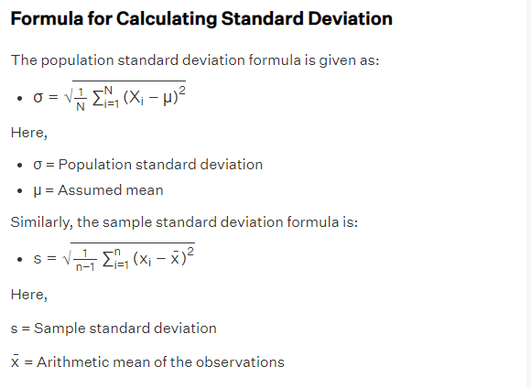

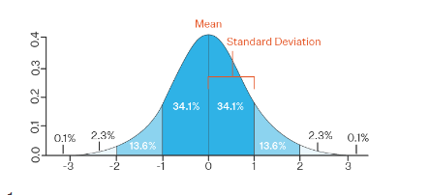

**Standard Deviation of Ungrouped Data**

standard deviation calculations differ for different different data. Standard deviation can be find by two methods:

* actual mean method
* assumed mean method

